Predicting The Energy Output Of Wind Turbine Based On Weather Conditions

By: Abhinav Kumar

Category: Machine Learning

Proposed System:
Our aim is to map weather data for energy production. We wish to show that even data that is publicly available for weather stations close to wind farms can be used to give a good prediction of the energy output. Furthermore, we examine the impact of different weather conditions on the energy output of wind farms.

Skills Required:
- IBM Watson Studio
- IBM Machine Learning
- IBM Cloud Object Storage
- Flask
Software Requirements:
- Operating system: Windows 10 9/8/19
- Coding Language: HTML, PYTHON
- IBM Watson Studio
- Machine Learning
- Cloud Object Storage

Outcome:
Develop an end to end web application to predict the energy output of the wind turbine based on weather conditions retrieved from the OpenWeather API. The application must be built with Python-Flask framework with the machine learning model trained & deployed on IBM Watson Studio.

Task Completed:

- Dataset Collection
- Create IBM Academic Initiative Account
- Create Cloud Object Storage Service
- Create Watson Studio Platform
- Create Machine Learning Services
- Train A Model In Watson Studio
- Deploy The Model
- Build Flask Application

Flowchart:

Database
Wind Energy Prediction
IBM Cloud

User Interface
Flask Server
Regression Model
Visualization
CSV File
Snapshot:
1. Resource List
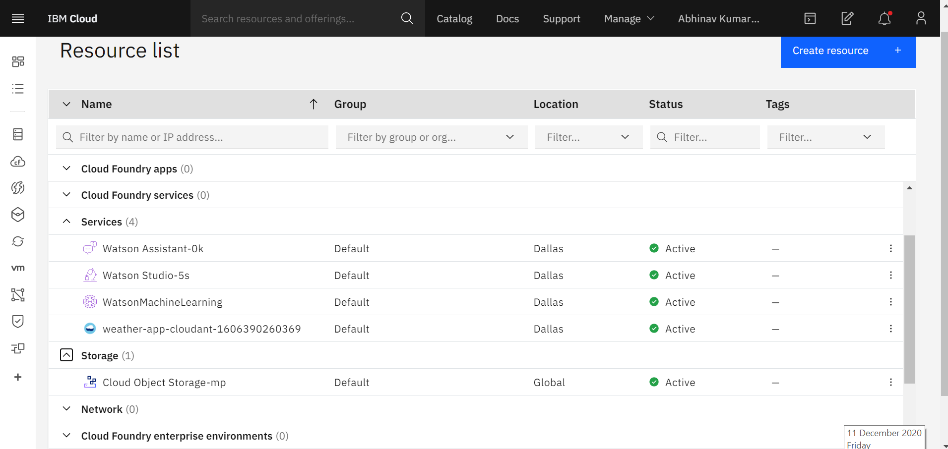

2.Data Visualization
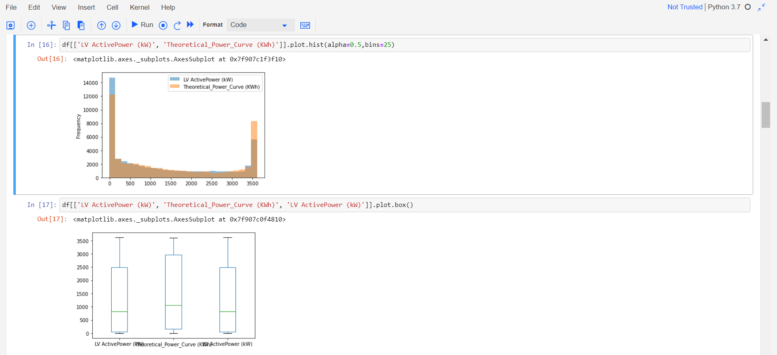
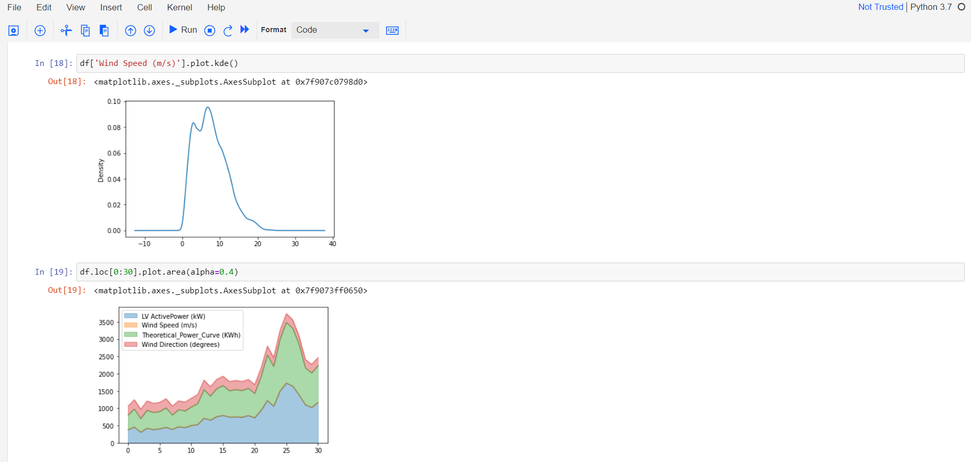

3. Source code of app.py
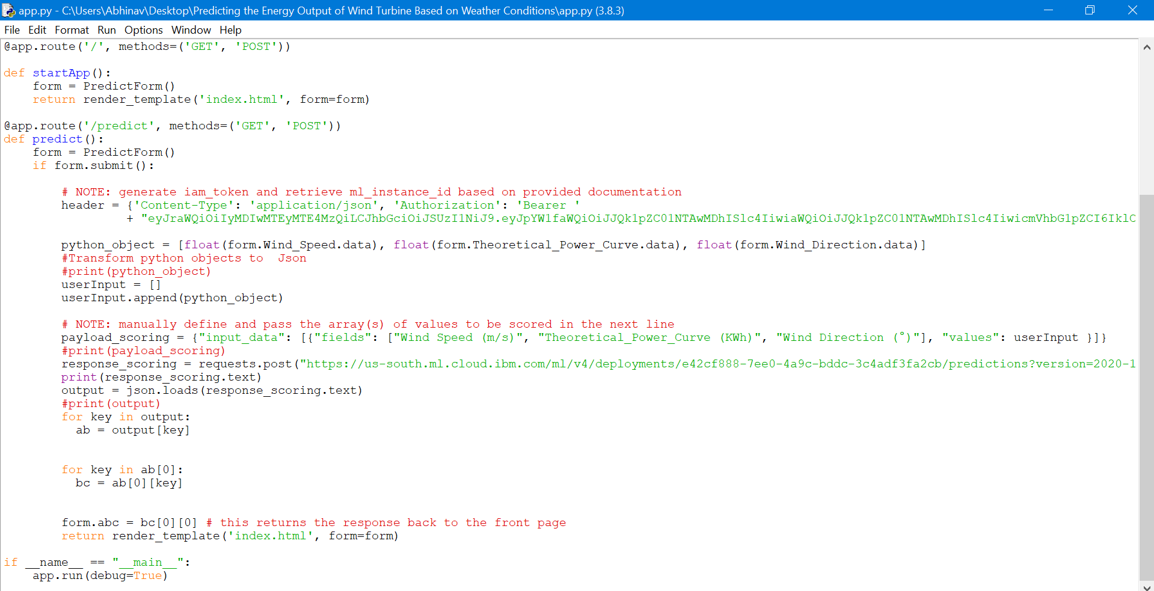

4. Source code of form.py
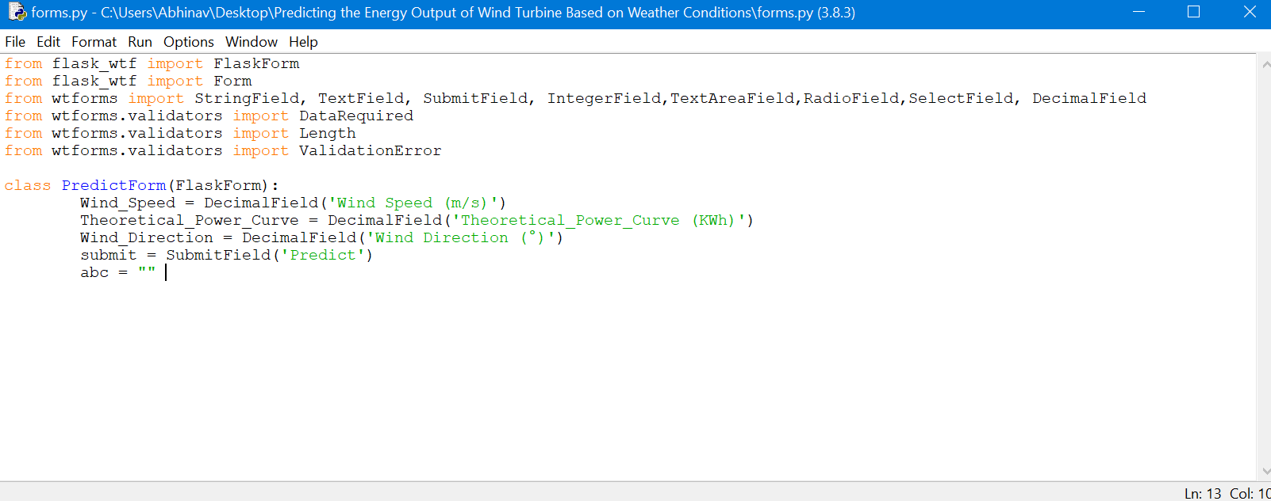

5. This is web interface of energy prediction
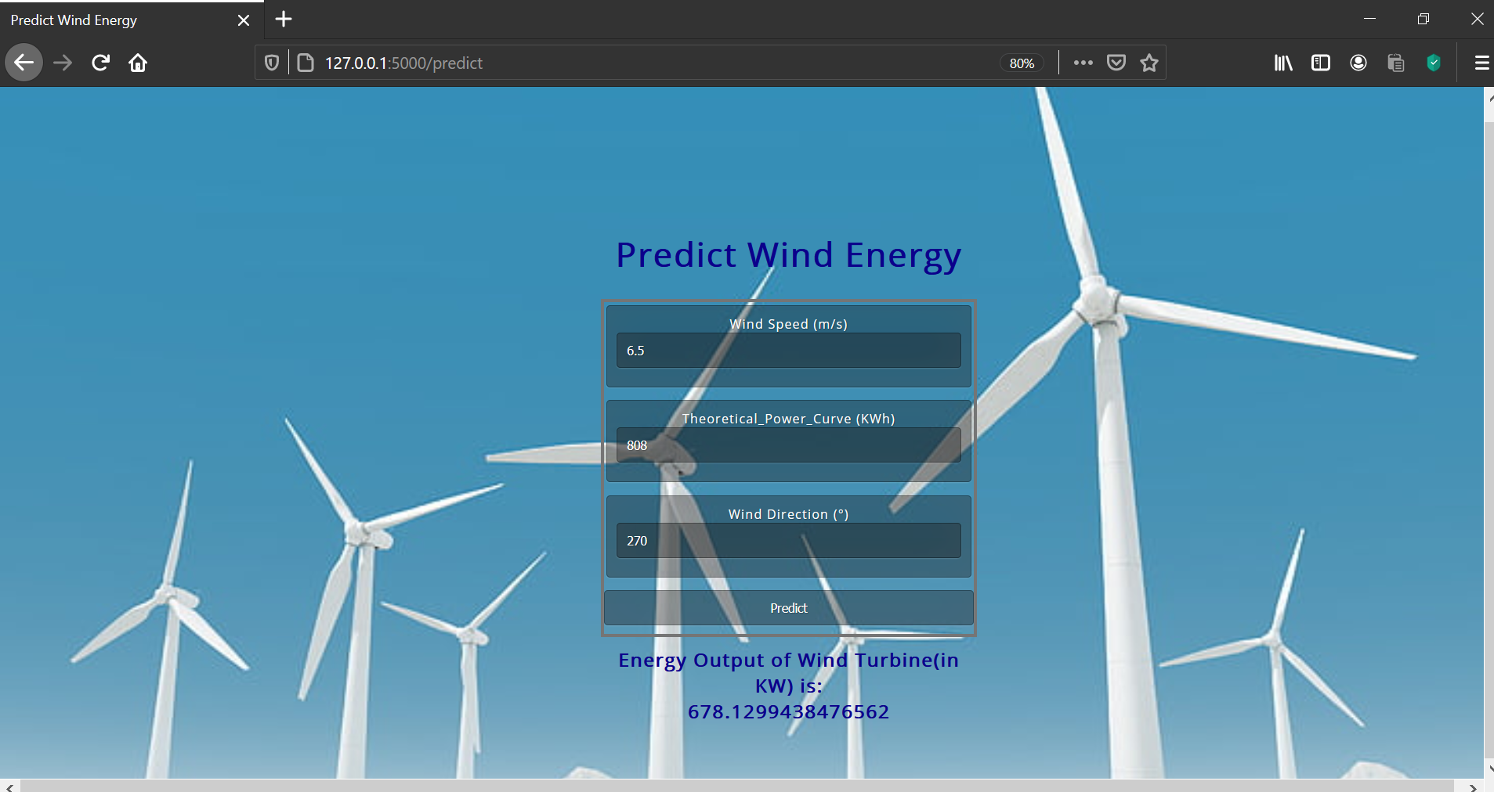

CONCLUSION
The model has been successfully deployed on IBM Cloud and the UI has been successfully created. The model used here is RandomForestRegressorwith an accuracy of upto 90%.

